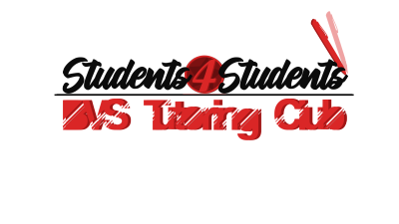

The Tutors’ Code of Honor

To maintain continuation standards within the **Students4Students** club, the following characteristics and behaviors must be exhibited by the individual:

1. The individual must maintain a GPA of 3.5 or higher
2. The individual must have a clean school record.
   1. Meaning, no behavioral infractions, at least for the last school year.
3. The individual must be a full-time Broward Virtual School student.
4. The individual must exhibit the following characteristics:
   1. Patience
   2. Responsibility
   3. Punctuality
   4. Efficiency
   5. Respect
   6. Encouragement
   7. Empathy
   8. Availability of time for **Students4Students** tutor meetings
5. When tutoring, the following must be done:
   1. The session must be recorded.
   2. The use of encouraging, polite words is required.
   3. Instead of saying phrases such as:
      1. “This is easy.”
      2. “That’s not how to do this.”
      3. “You are doing this wrong.”
   4. Use phrases such as:
      1. “This will get easy with practice.”
      2. “I’ll show you how to do this the correct way.”
      3. “You will eventually get this right with extra practice.”
   5. The camera is not allowed to be used, for the security of tutors as well as the security of the students.
   6. When screen sharing, an appropriate desktop background must be used, and tutors are to remain within the boundaries of the educational content being discussed as well as supportive materials.
   7. Attendance is to be taken.
   8. The tutor is to remain within the time allotted. Maximum: 1 hour per sesssion.
6. The Tutoring Session form is to be submitted after each tutoring session held.
7. Attendance to meetings is MANDATORY unless otherwise noted.
8. The recording table link is to be sent to the sponsoring teacher once the blackboard account is distributed to the individual and the session is created.

Failure to comply with these standards may result in consequences and penalties, including removal from the club.

Thank you for your time, dedication, and cooperation.

*-Students4Students*